**CS 557 Winter 2018**

**Project 4:** **Image Manipulation in a "Magic Lens"**

**Benjamin Fields**

[fieldsbe@oregonstate.edu](mailto:fieldsbe@oregonstate.edu)

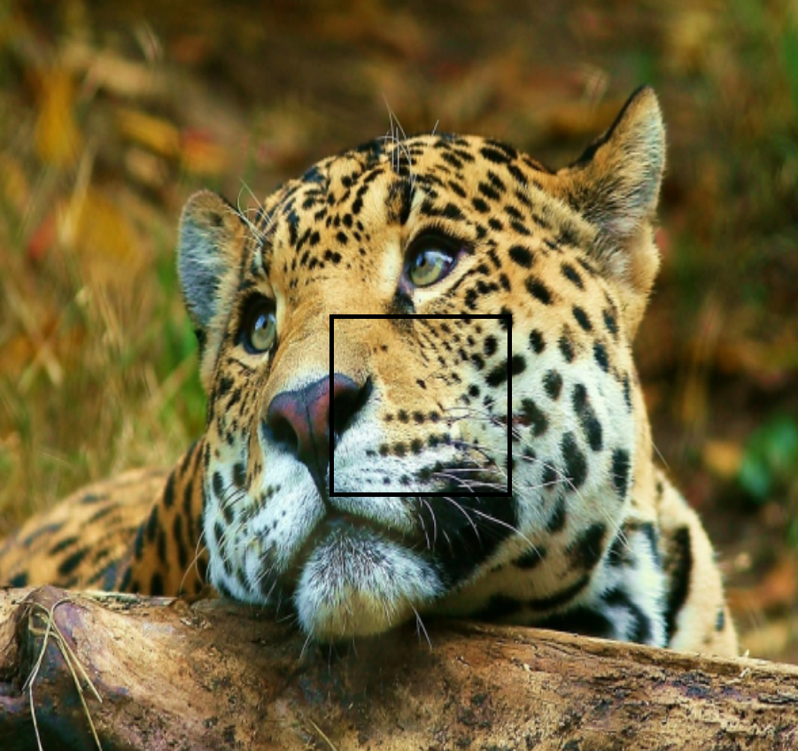 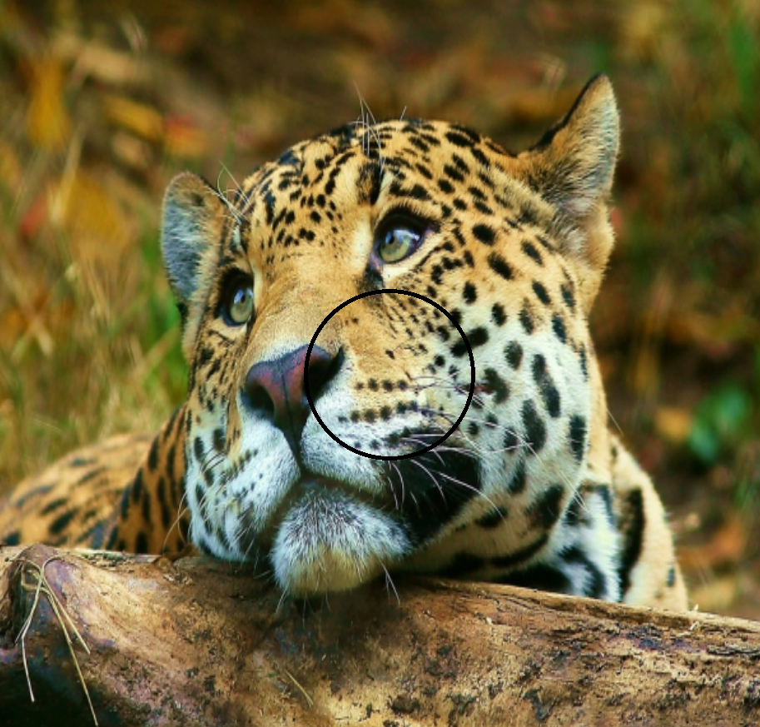

**Figure 1:** Initial images showing start lenses with no postprocessing. Upper image uses a square lens while the lower image uses a circular lens. The user can choose which one to use.

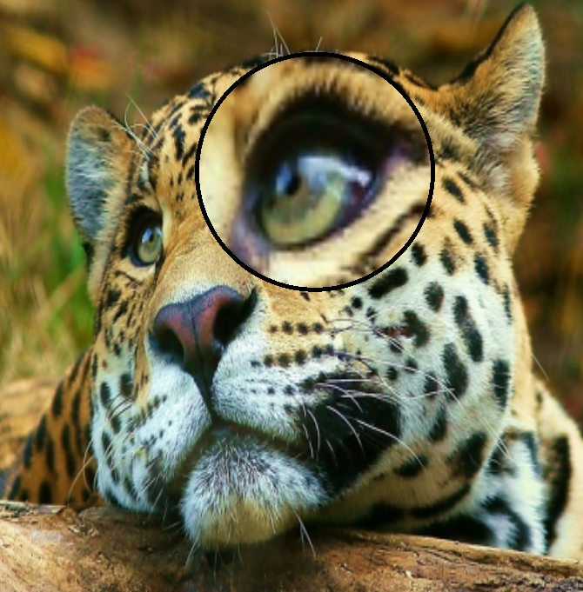

**Figure 2:** Example image showing the magnify effect in a circular lens.

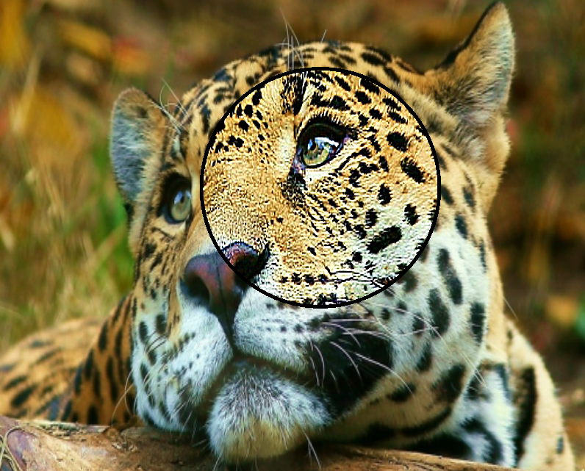

**Figure 3:** Example image showing the sharpening effect in a circular lens.

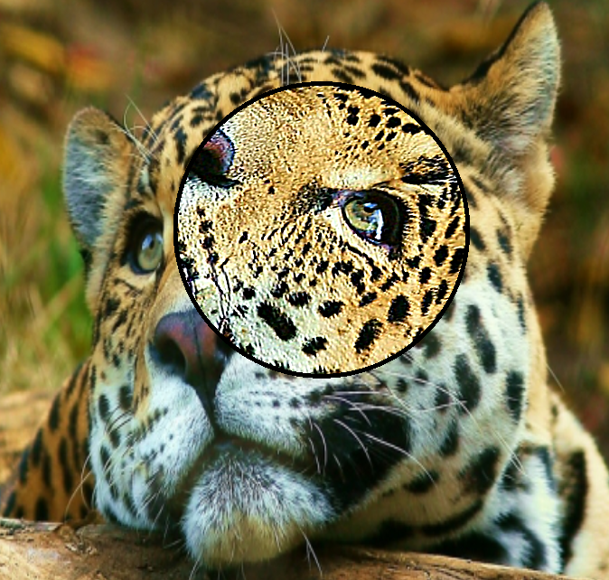

**Figure 4:** Example image showing the rotation effect in a circular lens.



**Figure 5:** Side by side image of an unsharpened image on the left and a sharpened image on the right.

**Video Can be found at the following link:**

<https://media.oregonstate.edu/media/t/0_h3g1fkn9>